# **Framing**

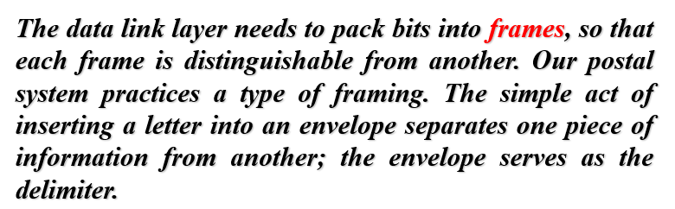

# **Responsibilities of the data-link layer**

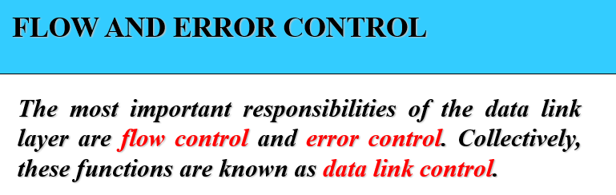

# **Flow Control**

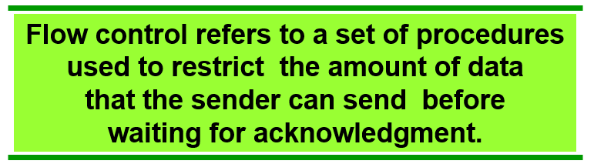

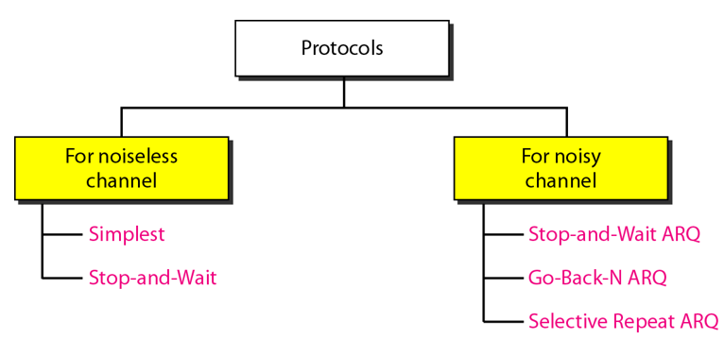

# **Noise-less channel**

## **Simplest**

No flow and error control and only unidirectional (sender to receiver).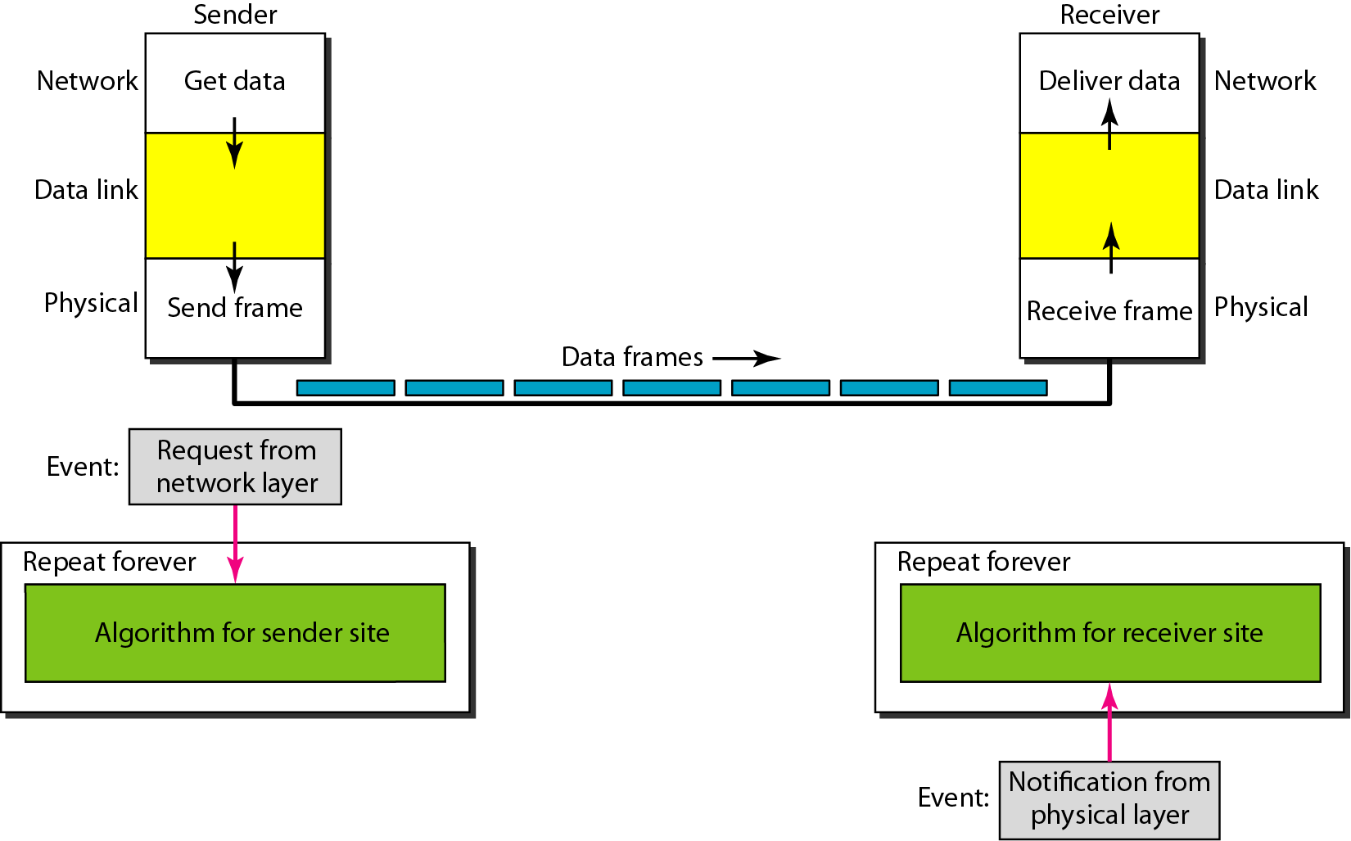

The sender sends the sequence of frames with-out even thinking about the receiver.

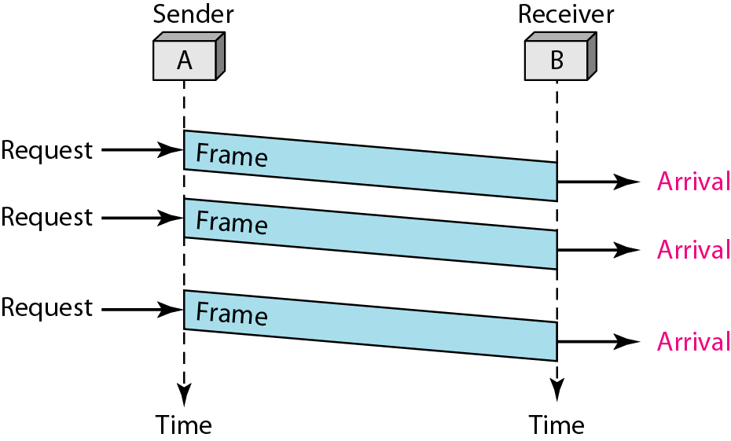

## **Stop and Wait**

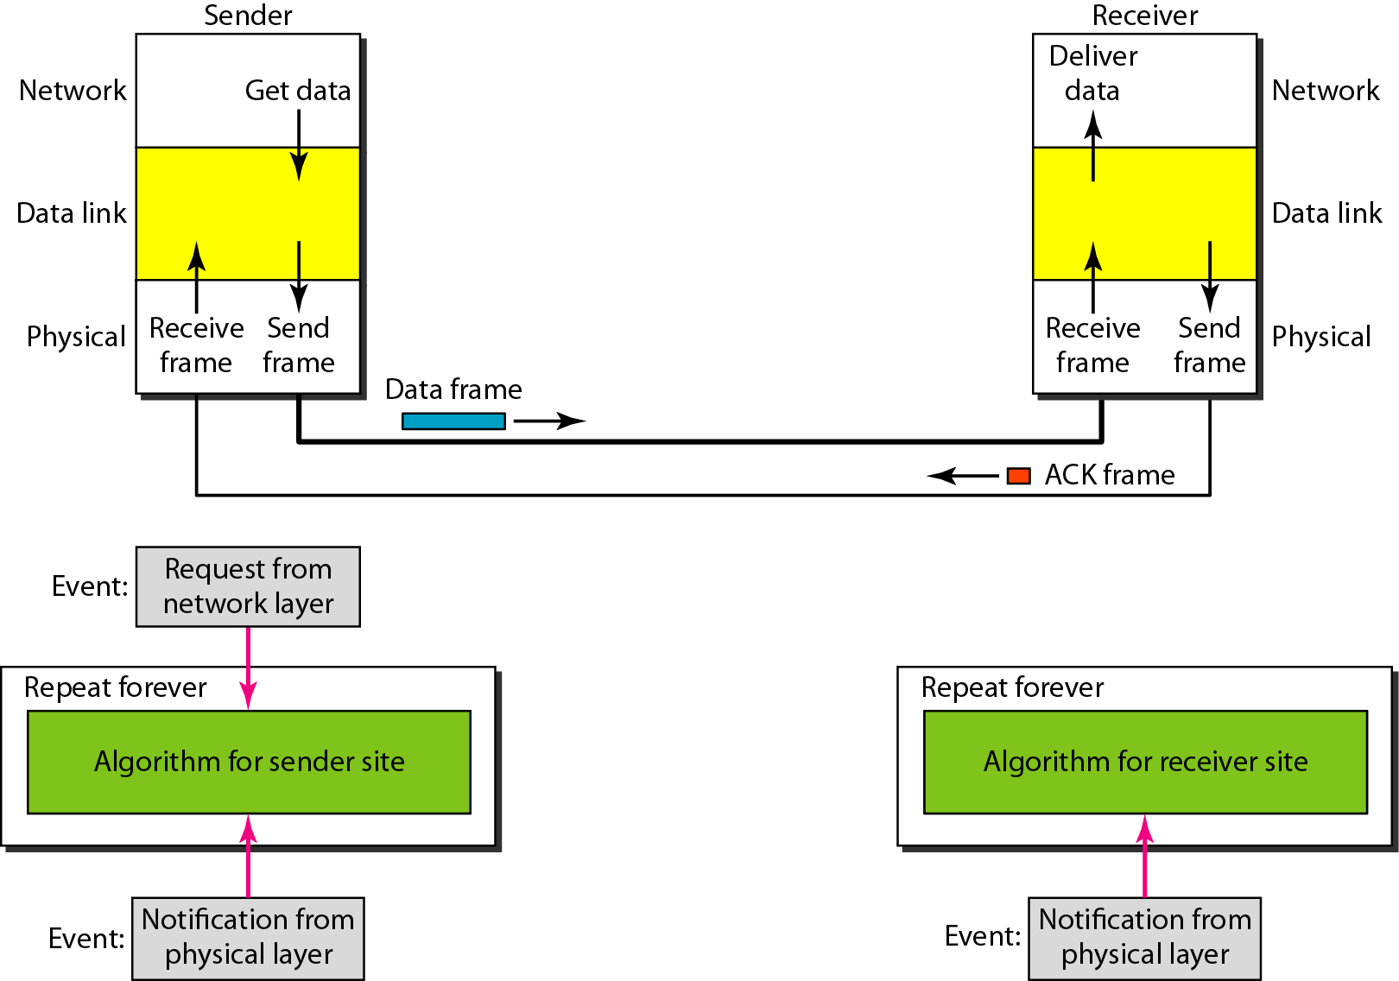

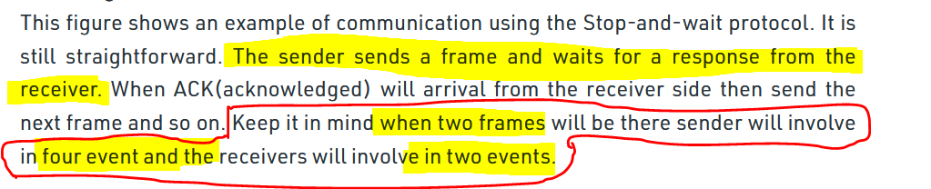

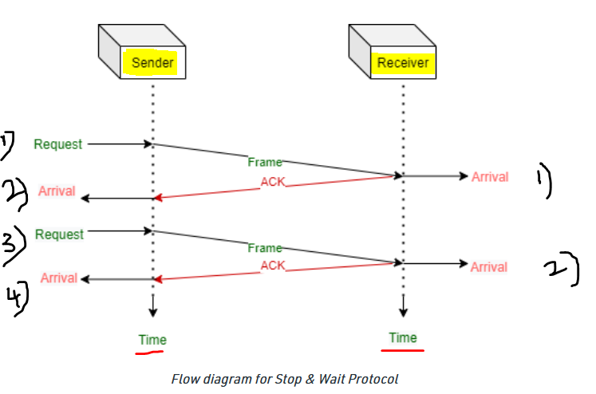

# **Noisy channel**

## **Stop and wait with ARQ**

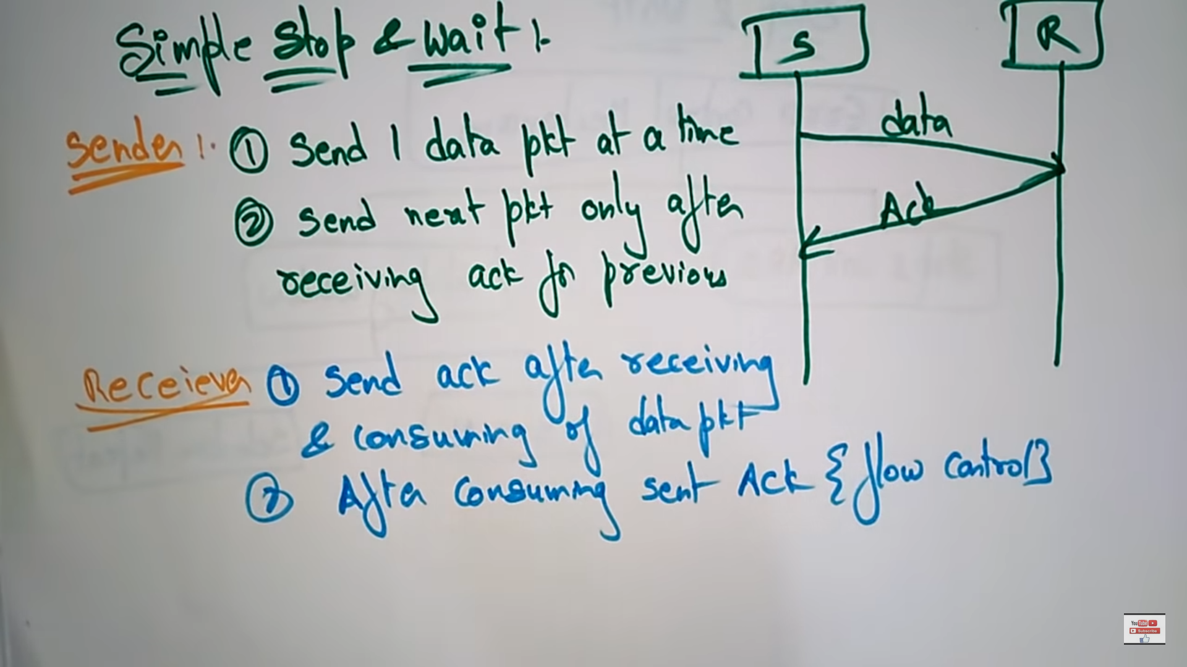

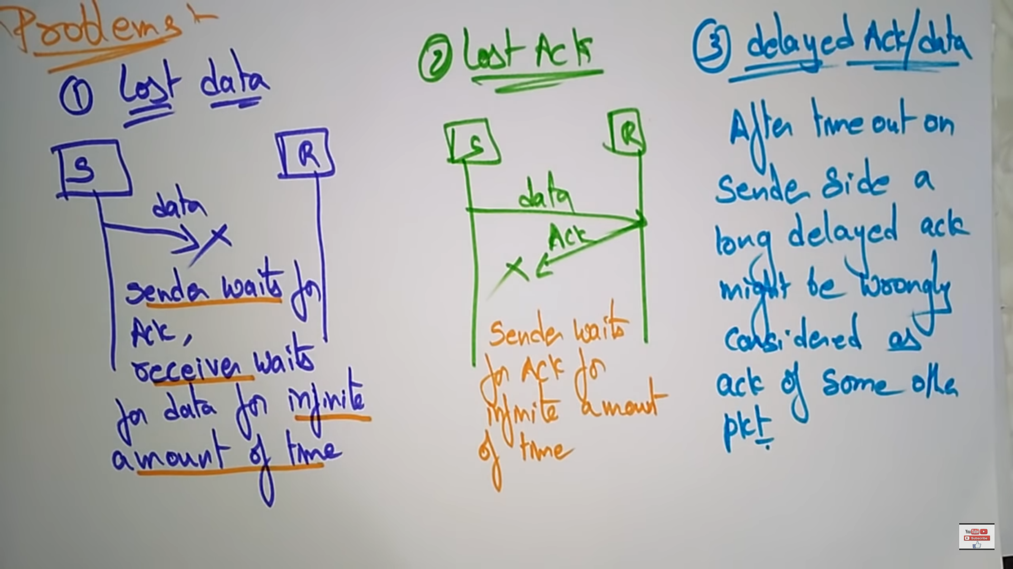

Since there is no buffer on both the sender and receiver side due to delay the sender doesn’t know / doesn’t keep track of sending the data bits.

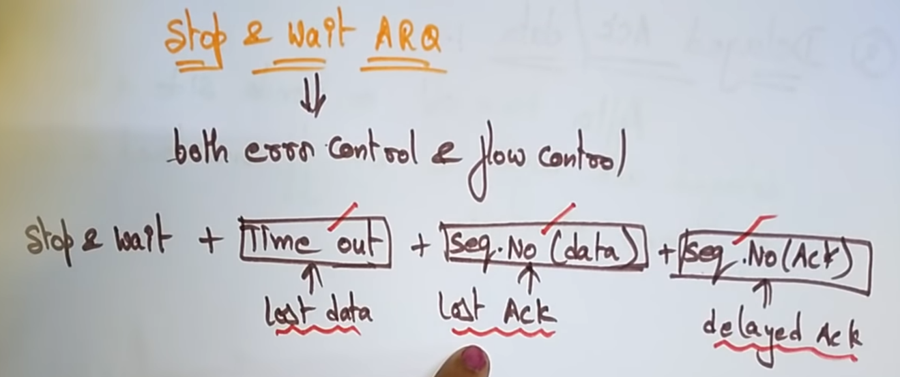

With **Time out** we can overcome the **problem of Lost data**.  
With **Sequence No(data)** we can overcome the **Lost acknowledgement.**  
With **Sequence No(acknowledgement)** we can overcome the **delayed acknowledgement.**

**Time out**

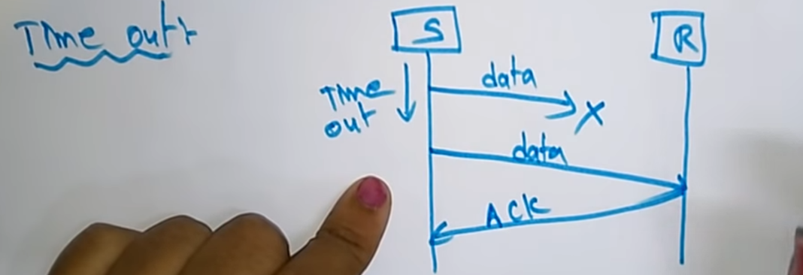

The sender will keep a clock(i.e 2s), within that 2s if the acknowledgement is not received by, the sender will once again send the same data once again. With this the problem of losing the data is prevented.

**Sequence No(data)**

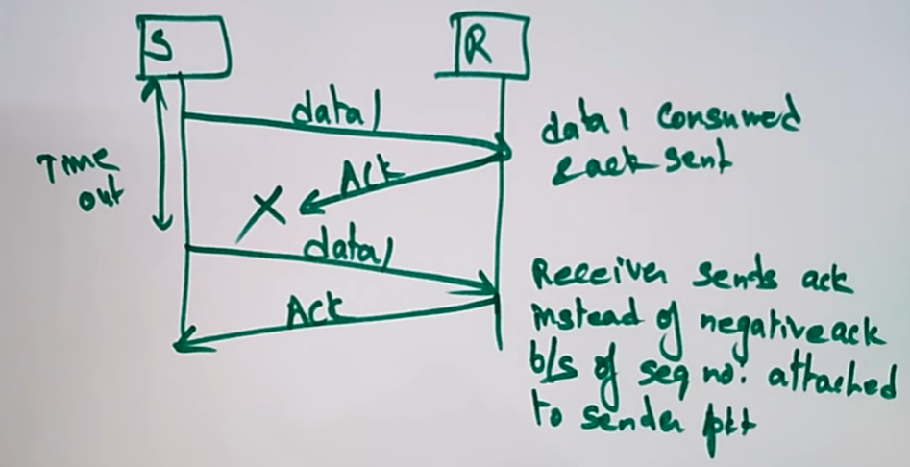

This is resolved by introducing the sequence number for sender data.  
Here the acknowledgement of data1 is not received by the sender. So data 1 is sent once again, on receiving the acknowledgement, the sender sends data2. With this the problem of lost acknowledgement is prevented.

**Sequence No(acknowledgement)**

This is resolved by introducing the sequence number for acknowledgement also.

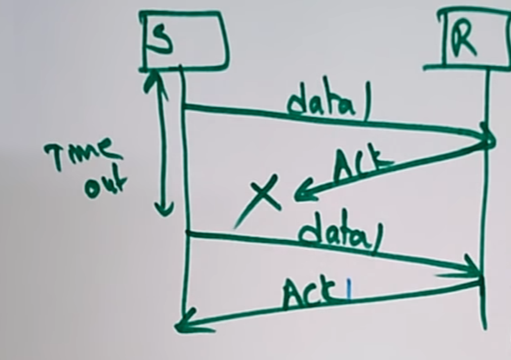



If the acknowledgement is lost or data is lost, the sender will resend the data once-again.



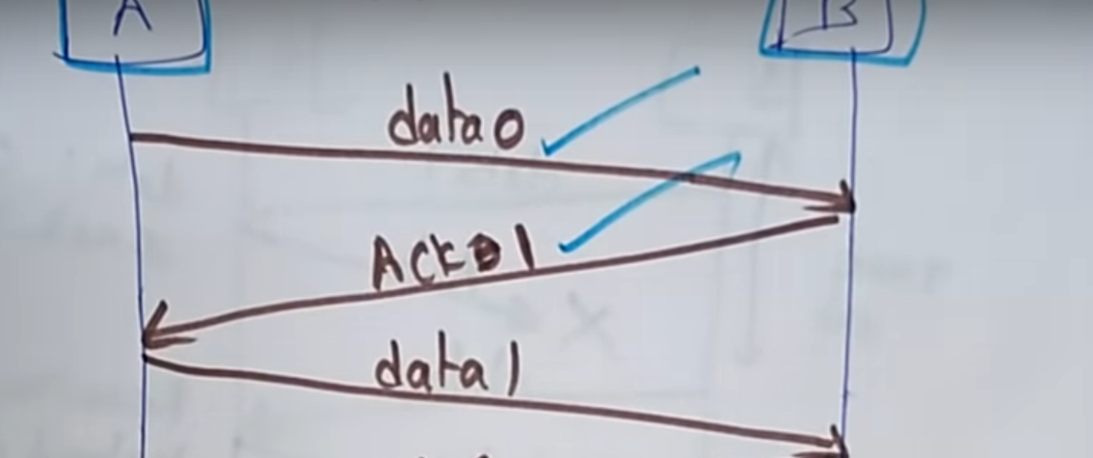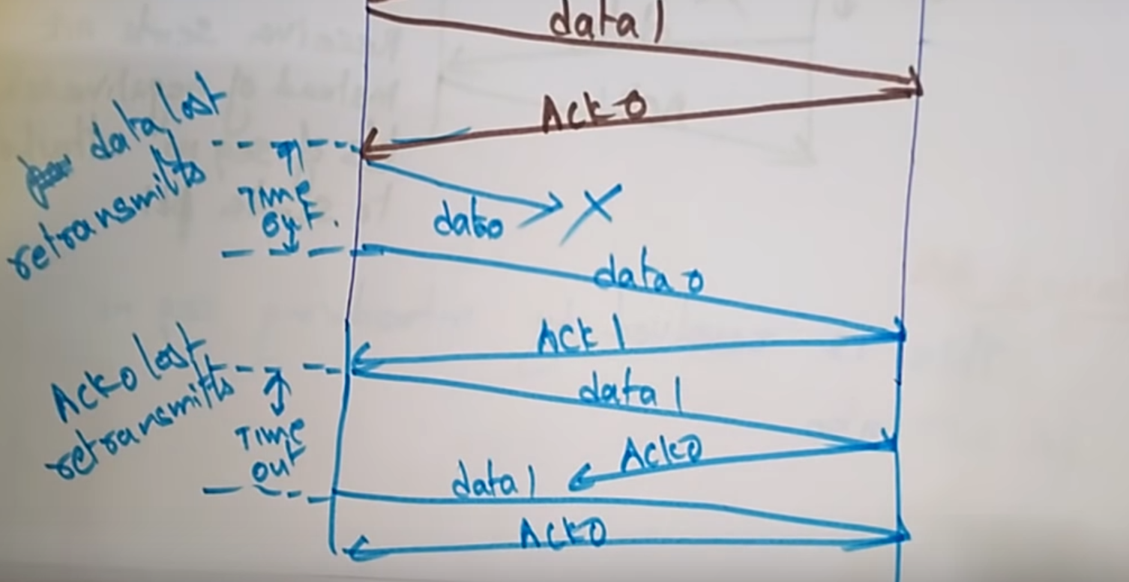



**Advantages:**  
* Noisy channel.  
* Flow and error control mechanism.  
* Timer implementation.

**Disadvantages:**\* Efficiency is very less.* Only 1 frame is sent at a time. **\*** No process of sending the packets together at a same time.

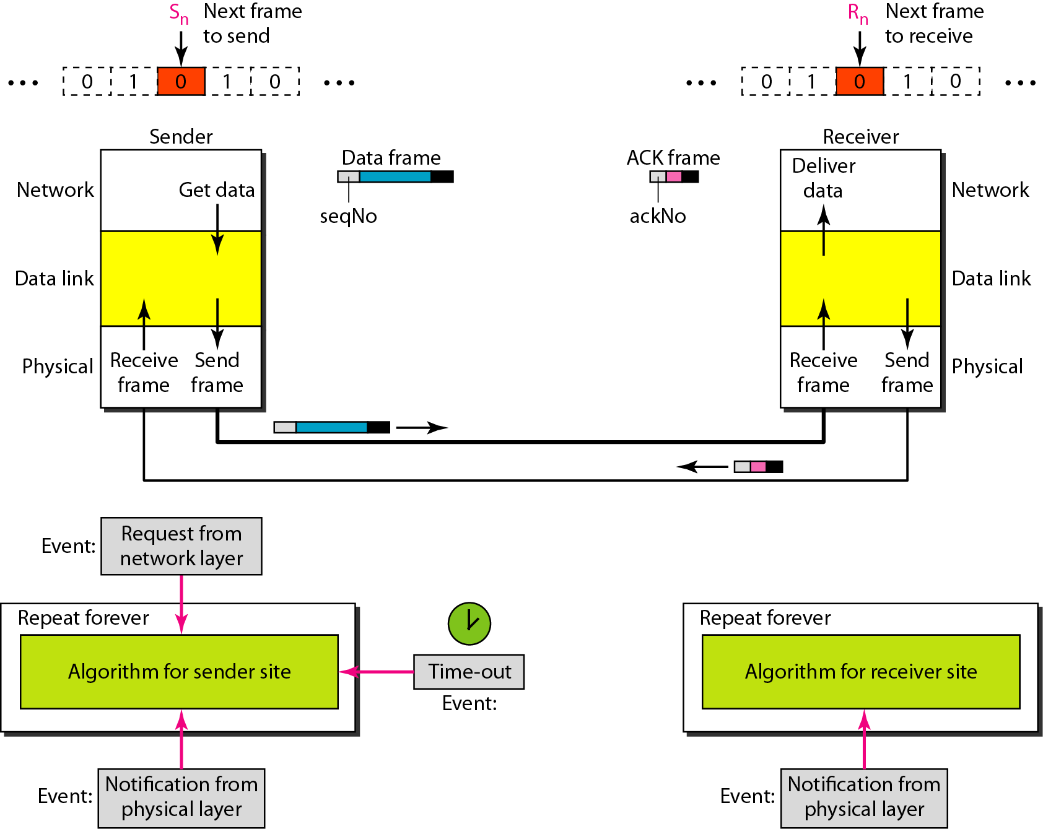

## **Go Back and ARQ**

### **Scenario-1**

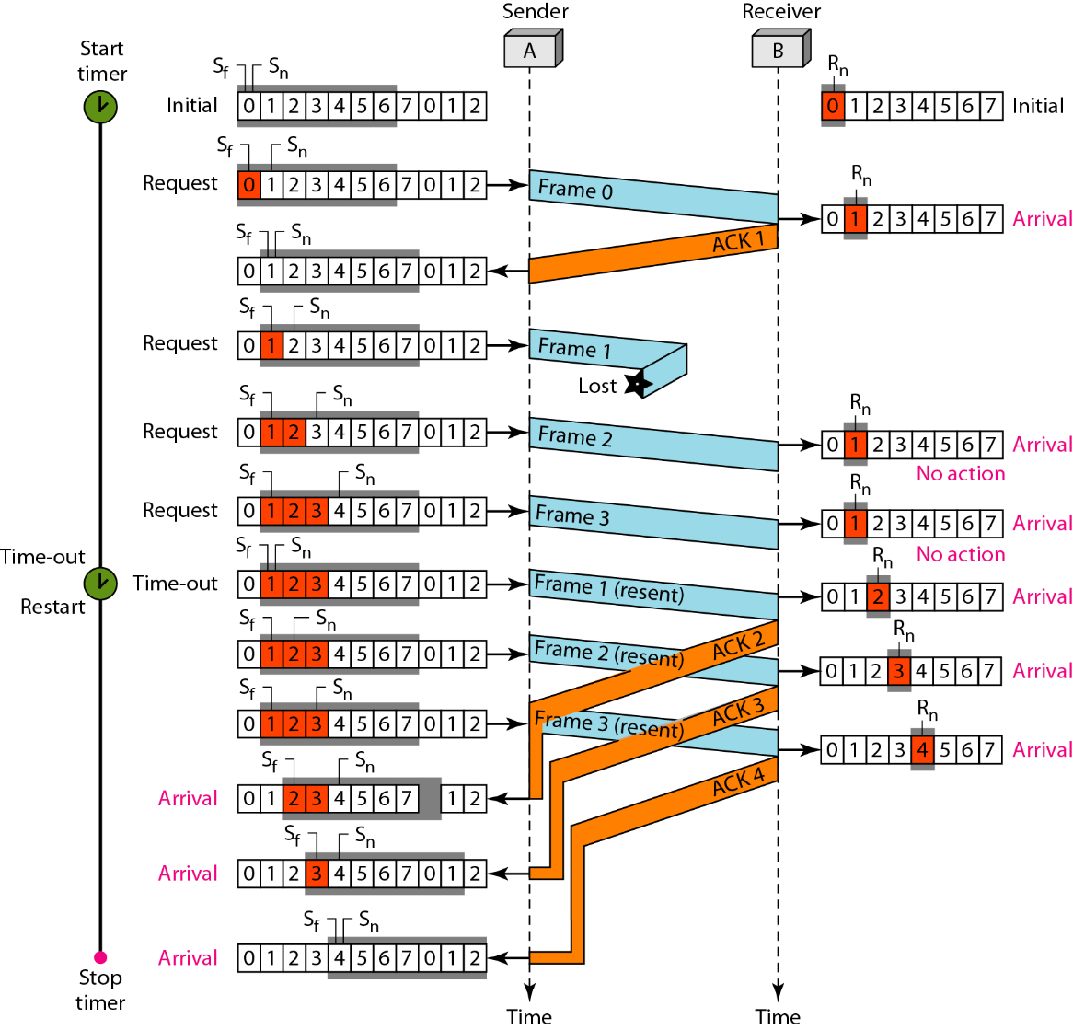

Figure 7 shows what happens when a frame is lost. Frames 0, 1, 2, and 3 are sent. However, frame 1 is lost. The receiver receives frames 2 and 3, but they are discarded because they are received out of order. The sender receives no acknowledgment about frames 1, 2, or 3. Its timer finally expires. The sender sends all outstanding frames (1, 2, and 3) because it does not know what is wrong. Note that the resending of frames 1, 2, and 3 is the response to one single event. When the sender is responding to this event, it cannot accept the triggering of other events. This means that when ACK 2 arrives, the sender is still busy with sending frame 3.

The figure shows that because of one packet lost, all following  
packets will need to be retransmitted, even if they have arrived at the destination 🡪 A great waste of bandwidth.

### **Scenario-2**

## **Selective Repeat Request ARQ**

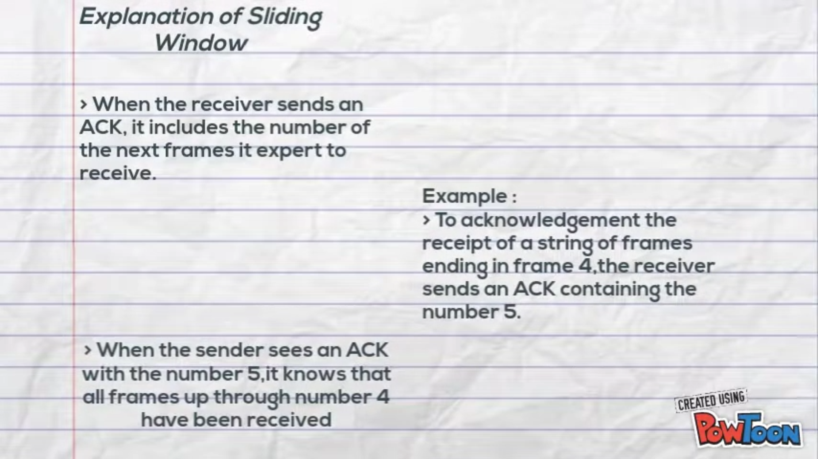

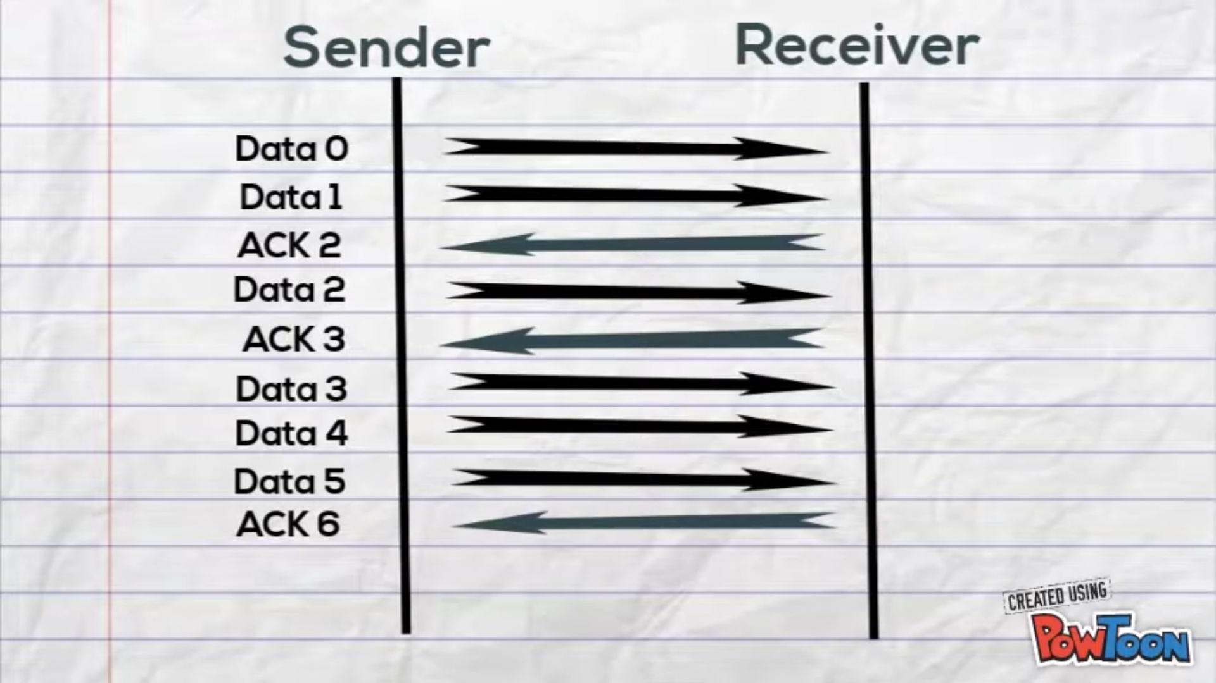

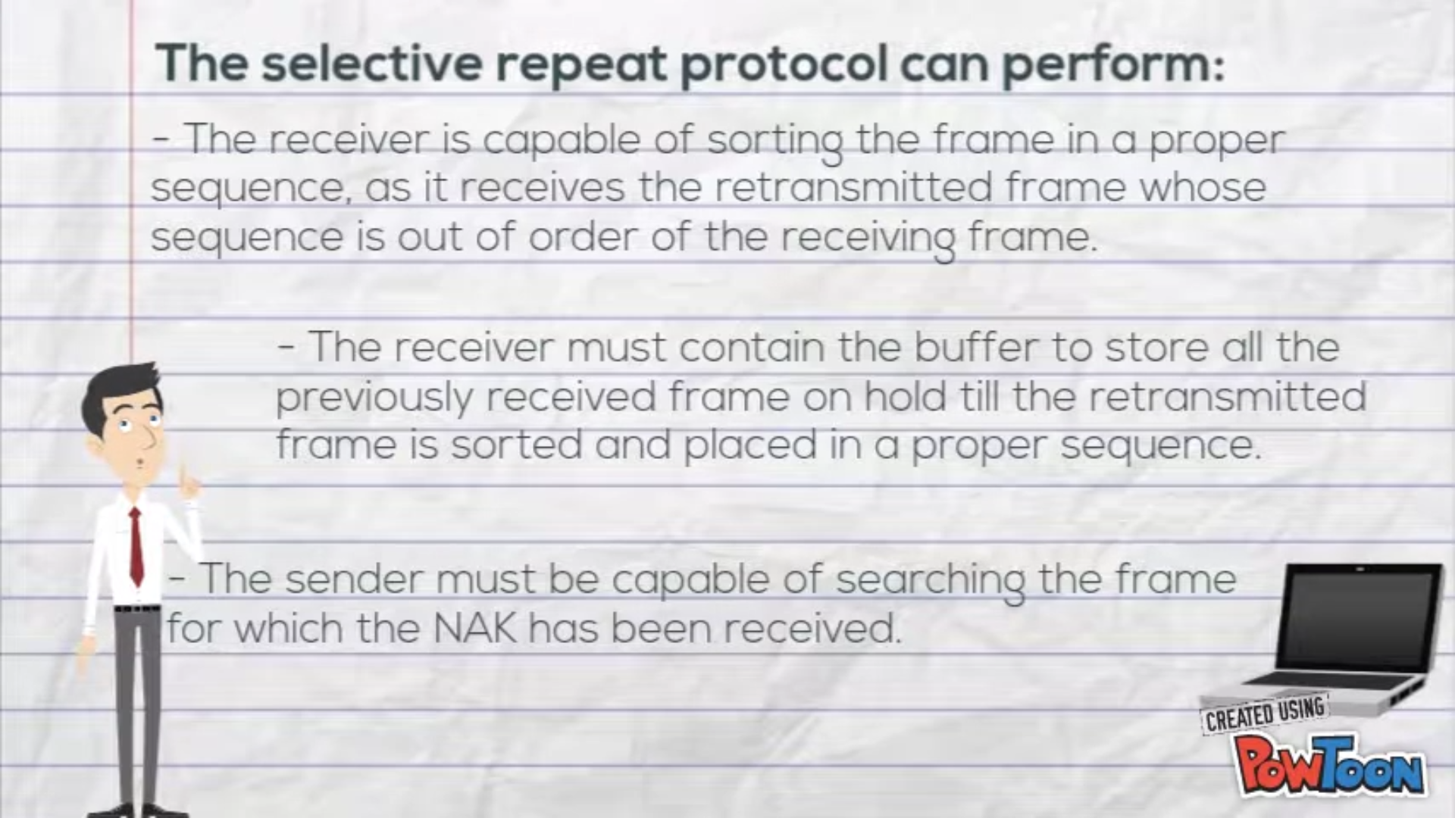

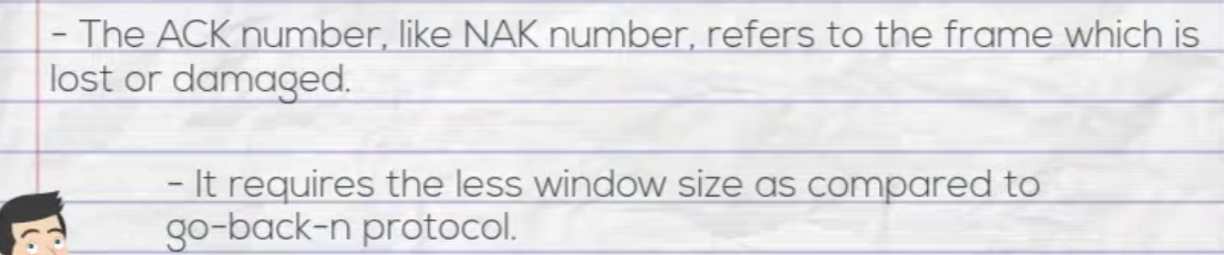

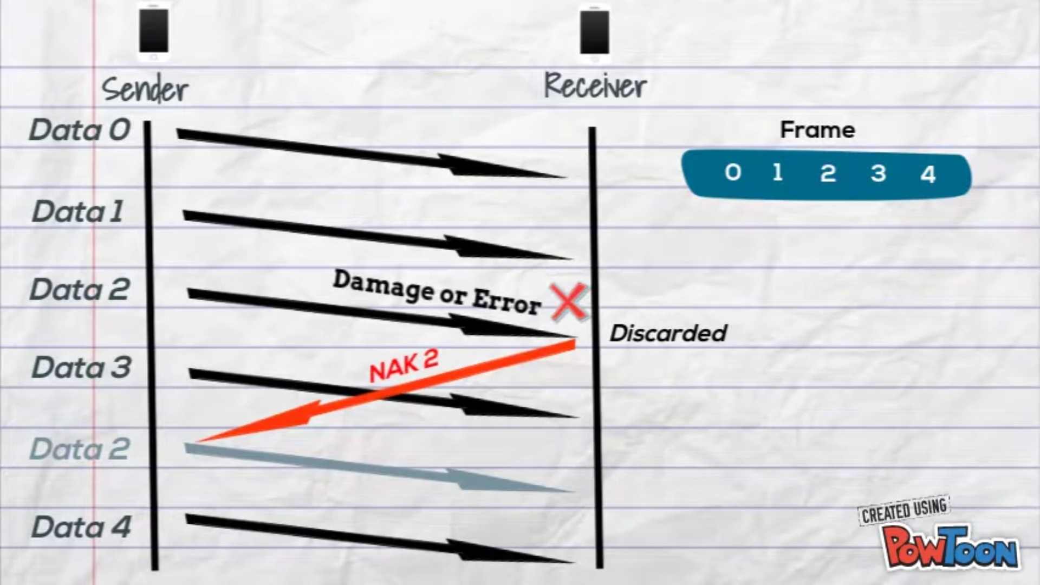

# Finite State Machine (FSM)



**Wait for call0 from above:**  
rdt_send(data)  
sndpkt = makepkt(0,data,checksum) 🡪 Sending data0  
udt_send(sndpkt)  
**start_timer**

**Wait for ACK1: (self-loop)**udt_rcv(rcvpkt) && ( corrupt(rcvpkt) || isACK(rcvpkt,0) ) 🡪 receiving data0

timeout 🡪 If the sender doesn’t receive the acknowledgment, it will resend the data and



udt_send(sndpkt) start the timer  
**start_timer**

**Wait for ACK1: (from 1 state to another)**udt_rcv(rcvpkt) && notcorrupt(rcvpkt) && isACK(rcvpkt,1)   
**stop_timer**



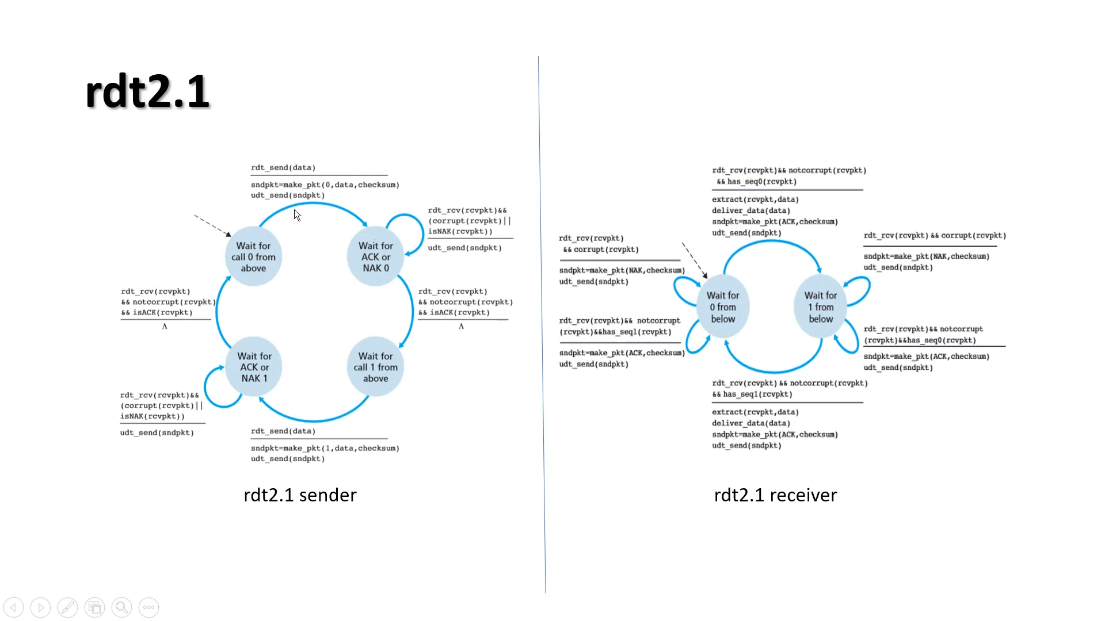

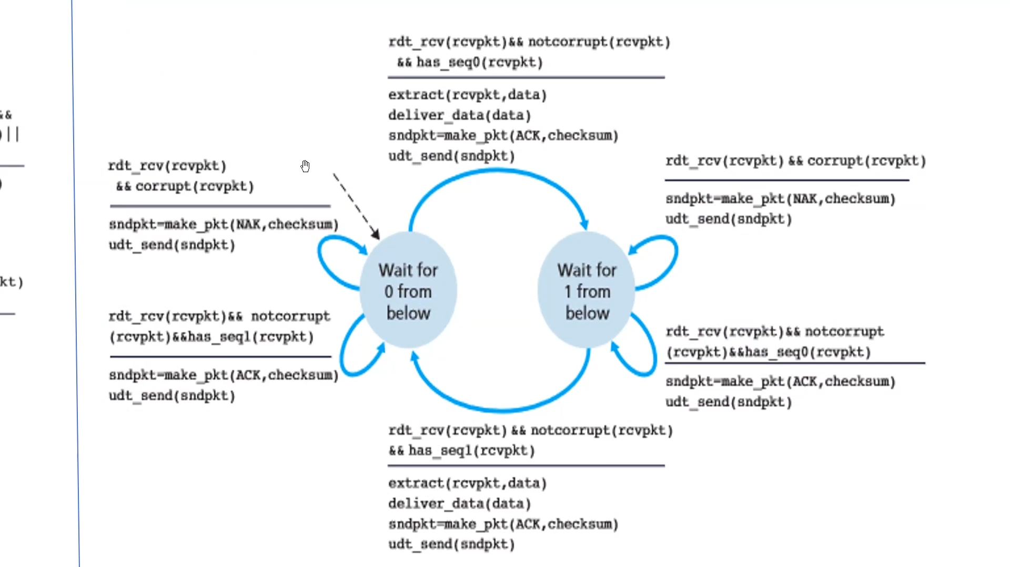

Wait for 0 from below   
Will except the data with sequence number 0

Will accept sequence1 also send ACK, but will not extract the data from the packets received.

Wait for 1 from below   
Will except the data with sequence number 1

# Implementation

## Sender

1)Data must be sent from the network layer to physical layer  
Data will be coming in the form of packets, these packets must be converted into frames and then sent to the physical layer

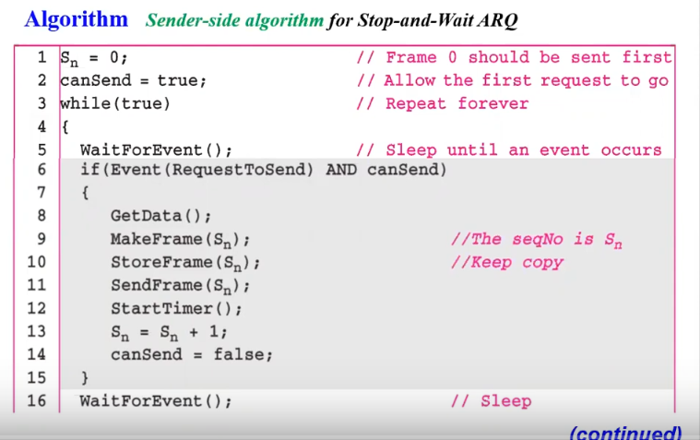

After getting the data from network layer, we will create a frame with sequence number and store the frame, in-case if the frame is lost we have to resend the frame once again.  
Send the frame and the start the timer, we will increase the sequence number.  
flag canSend=False (until we receive the acknowledgment next frame can’t be sent)

### 2) When the acknowledgement have arrived

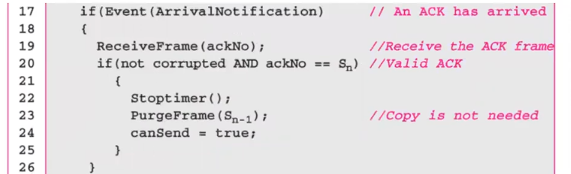

First we Should check if the frame is not corrupted and the acknowledgment number is equal to the next frame which we want to send.  
We will stop the timer, purge the frame which was sent and make the flag true, indicating the completion of the event.

### 3) When the timer was expired

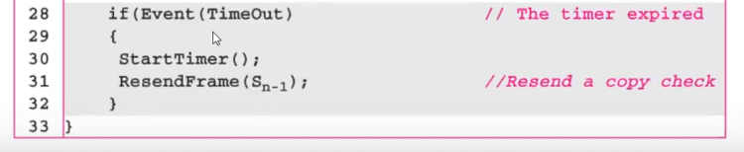

## Receiver

